
Monday 27 January 2014
Aldermore launches pioneering Customised Fixed Rate savings account for SMEs

- New concept in savings allowing 5 million SMEs to save on their own terms
- Control: Gives businesses greater control over their savings
- Flexible: Choose a maturity date and interest rate that suits your business
- Speed: The account can be opened and funded within 15 minutes
- Maximise return: Select exact date of maturity to maximise returns
- Transparent: No hidden charges or gimmicks
Aldermore, Britain's leading challenger bank, has today launched its Customised Fixed Rate Account (CFRA) for business savers, which marks an exciting new concept in the savings market by allowing SMEs, sole traders and the self-employed to select the exact maturity dates and interest rates to suit their saving needs.

The CFRA is available from today to the 5 million SMEs in Britain who would like greater control, transparency and flexibility in their savings accounts, alongside the ability to generate maximise returns by selecting the maturity date of their choice.
SMEs need to plan ahead for outlays of wages, tax payments and investments at particular dates in the future, so having a flexible online-only account that pays top rates while allowing them to release funds on precisely the right day ensures maximum returns and convenience.

With no hidden charges or misleading introductory offers, the CFRA is a transparent and simple way for both new and existing Aldermore business customers to open bespoke savings accounts on their own terms.
The account can be opened and funded within 15 minutes at any time of day or night and accounts can be opened with a minimum deposit of £1,000 up to a maximum of £1m.
The term dates available range from 60 days to five years. SMEs can select an exact date by using a simple and intuitive dial system that allows customers to design their own Fixed Term account choosing a maturity date that is right for them (as illustrated below).

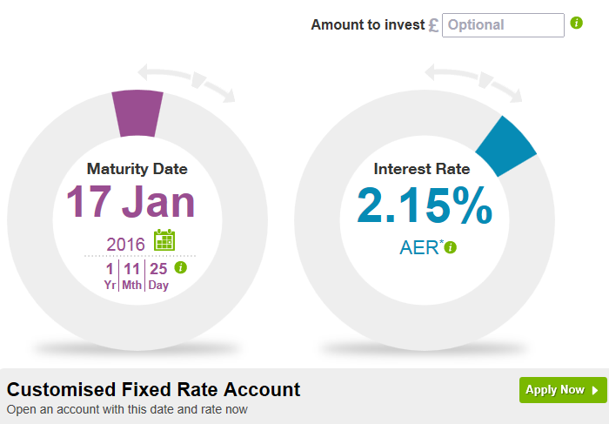

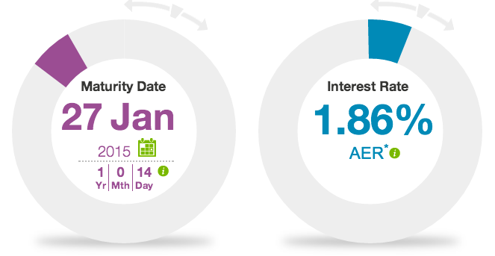

Alternatively, business owners can select an exact rate, ranging from 1.25% to 3% AER*, and see the corresponding term for that rate.
Aldermore Savings Managing Director Simon Healy says: “We are really excited to be launching this revolutionary concept in savings allowing savers to have complete control and choice over their business savings. Customers no longer have to leave their business savings languishing in a low interest account because they can’t find a term that’s right for them, they can save on their terms – maximising their returns with a fixed rate of interest until the exact date they want their money back.
“From those who are self-employed or sole traders to SMEs and larger organisations, the Customised Fixed Rate Account represents a speedy and efficient way of maximising returns for the 5 million businesses in the UK.

“For example, if you have an invoice to pay booked in on a certain date, or staff bonuses at the year-end you can put these funds away until they are needed, ensuring they generate the maximum return.

“We are exploring options for a retail launch in the future.”

Small business owner and CFRA customer Paul Chiles says: “What makes the Aldermore business account useful is that I can put the money away for as long as I want and it gives me a better return than other High Street banks. For example, I put away money to pay corporation tax that I don’t need until November 2014, nine months after my company’s year-end, so the CFRA account allows me to specify my own maturity date, which is what I need.”

**ENDS**

*AER stands for Annual Equivalent Rate and illustrates the interest if paid and compounded once each year.

For further information and case studies journalists can contact:

Nicola York
Nicola.york@cicero-group.com
Office: 0207 297 5965
Mobile: 07841 864 107

OR

Mike Robb
Mike.robb@cicero-group.com
Office: 0207 947 5315
Mobile: 07572 730123

NOTES TO EDITORS
Case studies
Case studies and photographs of CFRA customers are available on request.

Further details (for full product details see here)
- A business must be registered and trading in the UK;
- Multiple accounts can be opened once a customer’s first account is open;
- Internet access is essential as all Aldermore’s business savings accounts are online accounts and are opened and managed online;
- Customers must be UK residents aged 18 or over;
- At least £1,000 must be kept in accounts at any one time. An interest rate of 0.05% AER is payable on balances below £1,000;
- No withdrawals or closures before the maturity date.
About Aldermore: (www.aldermore.co.uk)

Aldermore is a new British bank and one of the best capitalised banks in the UK. With backing provided by AnaCap and Morgan Stanley Alternative Investment Partners, Morgan Stanley’s Private Equity Fund of Funds business and new investment from the consortium of funds managed by Goldman Sachs Asset Management, Honeywell Capital Management and the Ohio Public Employees Retirement System, Aldermore raises deposits from consumers and lends to homeowners and small and medium sized businesses.

Aldermore participates in the Funding for Lending Scheme. Aldermore does not participate in investment banking or proprietary trading activity and has not been involved in any banking activities or the marketing of any exotic products which have been the cause of problems for so many financial institutions.

As a British bank, Aldermore is regulated by the Prudential Regulation Authority (PRA) and the Financial Conduct Authority (FCA), which means customers’ savings are protected up to the statutory limit of £85,000 per person under the Financial Services Compensation Scheme (FSCS). Aldermore is also a member of the Council of Mortgage Lenders.

Aldermore markets its lending products via professional financial advisers and specialist commercial finance brokers located throughout England, Scotland and Wales.

About AnaCap Financial Partners LLP: (www.anacapfp.com)

AnaCap Financial Partners is Europe’s largest specialist private equity investor in the financial services sector. Based in London and investing across Europe, AnaCap advises funds with €1.7 billion under management across Private Equity and Credit Opportunities vehicles, as well as co-invest.

AnaCap’s Private Equity funds invest in European financial services businesses with strong, highly motivated management teams and provide the support and expertise necessary to create exceptional returns. Our network of relationships, which extends across the globe and throughout the financial services sector, enhances our ability to source investment opportunities, support high-quality management teams and identify and capitalise on growth strategies.

AnaCap’s role is to provide capital, strategic guidance and operational expertise to build highly efficient and scalable businesses. Furthermore, our considerable experience of working with regulators through multiple investments in commercial and retail banks positions us as a favourable counterparty for many sellers.

The name AnaCap, an abbreviation of 'Analytics before Capital', forms the bedrock upon which our organisation is built. AnaCap takes a highly analytical approach towards the valuation and due diligence of potential investments, which is facilitated by the use of proprietary tools to price assets and which leverages our best-in-class, in-house capabilities.
The success of AnaCap’s private equity and credit investment strategies and teams has attracted investment from highly regarded global institutional investors including Goldman Sachs, Allianz, Morgan Stanley Alternative Investment Partners, Honeywell, State of New Jersey and Adams Street Partners.
Will Bray
Associate
Cicero Group
+44 (0)20 7947 5317
www.cicero-group.com

